

FACE RECOGNITION AND MONITORING IN AN UNCONTROLLED ENVIRONMENT

A PROJECT REPORT
Submitted by

ROHITH P (20ITR089)
SHASIANAND T (20ITR095)
SUHAIL AHAMED M (20ITR109)
VAISHALI R (20ITR119)

in partial fulfillment for the award of the degree

of
BACHELOR OF TECHNOLOGY
in
INFORMATION TECHNOLOGY

VELALAR COLLEGE OF ENGINEERING AND TECHNOLOGY,
(AUTONOMOUS)
ERODE-638012
MAY 2024

FACE RECOGNITION AND MONITORING IN AN UNCONTROLLED ENVIRONMENT

A PROJECT REPORT
Submitted by

ROHITH P (20ITR089)
SHASIANAND T (20ITR095)
SUHAIL AHAMED M (20ITR109)
VAISHALI R (20ITR119)

in partial fulfillment for the award of the degree

of
BACHELOR OF TECHNOLOGY
in
INFORMATION TECHNOLOGY

VELALAR COLLEGE OF ENGINEERING AND TECHNOLOGY,
(AUTONOMOUS)
ERODE-638012
MAY 2024

BONAFIDE CERTIFICATE

BONAFIDE CERTIFICATE
Certified that this project report “FACE RECOGNITION AND MONITORING IN AN UNCONTROLLED ENVIRONMENT” is the bonafide work of ROHITH P (20ITR089), SHASIANAND T (20ITR095), SUHAIL AHAMED M (20ITR109) and VAISHALI R (20ITR119) who carried out the project work under my supervision.

SIGNATURE | SIGNATURE
Dr. S. VIVEKA, M.E., Ph.D., | Dr. R. MYNAVATHI, M.E., Ph.D.,
SUPERVISOR | HEAD OF THE DEPARTMENT
Professor, | Professor,
Department of IT, | Department of IT,
Velalar College of Engineering | Velalar College of Engineering
and Technology, | and Technology,
Thindal, Erode-638012. | Thindal, Erode-638012.

Submitted for the Semester Project viva-voce examination held
on ________.

INTERNAL EXAMINER EXTERNAL EXAMINER
ACKNOWLEDGEMENT
ACKNOWLEDGEMENT

ACKNOWLEDGEMENT

On the glorious occasion of having consummated our project, we would like to thank our honorable secretary and correspondent Thiru S. D. CHANDRASEKAR, B.A., Secretary, Vellalar Educational Trust, for having provided ample facilities to complete the project.
We express our deep sense of gratitude and sincere thanks to our beloved Principal Dr. M. JAYARAMAN, Ph.D., Velalar College of Engineering and Technology for his patronage and encouragement.
We like to express our heartiest thanks to our honorable
Dean Prof. P. JAYACHANDAR, M.E., for giving us the opportunity and continuous inspiration to carry out this project.
We express our gratitude to Dr. R. MYNAVATHI, M.E., Ph.D., Professor and Head, Department of Information Technology for her valuable guidance and encouragement.
We thank our Project coordinator Dr. M. KAVITHA, M.E., Ph.D., and our project supervisor Dr. S. VIVEKA, M.E., Ph.D., Department of Information Technology for their valuable guidance and support. We were immensely profited by their comments and reviews. We also extend our thanks to our beloved parents and friends for their technical support, guidance, and encouragement in all aspects throughout the work.
We profoundly thank all teaching and non–teaching staff members of Information Technology.

ABSTRACT

ABSTRACT

Facial recognition is an important subject in computer vision, evolving with the aid of deep learning and extensive datasets. End-to-end deep face recognition systems, which process natural images or video frames to generate facial features for identification. Convolutional Neural Networks operate at multiple resolutions, proving beneficial in monitoring closed environments such as classrooms, conferences, and events. In the realm of big data, the face recognition technology has expanded, especially in closed environments. Face recognition system in real-time proves useful for monitoring these closed settings. Two key considerations in face recognition include enhancing the accuracy of real-time face recognition and ensuring the stability of video processing systems. Through a comprehensive analysis, the face recognition system demonstrates an impressive accuracy rate, particularly valuable in closed environments.

Keywords – Face detection, Face recognition, Convolutional Neural Network.

TABLE OF CONTENTS
CHAPTER CHAPTER NAME PAGE NO
NO
ABSTRACT vii
LIST OF FIGURES xi
LIST OF ABBREVIATIONS xii

1. INTRODUCTION 1
1.1 DOMAIN KNOWLEDGE 1
1.1.1 FACE RECOGNITION 1
TECHNIQUES
1.1.2 LIBRARIES AND TOOLS 2
1.1.3 FACE DETECTION 4
1.1.4 FACE MATCHING 6
1.1.5 FACIAL FEATURE EXTRACTION 8
1.2 OBJECTIVE 10
1.3 PROBLEM STATEMENT 13
1.4 SCOPE 16
2. LITERATURE SURVEY 19
2.1 LITERATURE SURVEY 19

3. SYSTEM ANALYSIS 21
3.1 EXISTING SYSTEM 21
3.1.1 DRAWBACKS OF EXISTING 24
SYSTEMS
3.2 PROPOSED SYSTEM 24
3.2.1 ADVANTAGES OF PROPOSED 28
SYSTEMS

4. SYSTEM DESIGN 30

4.1 INPUT DESIGN 30

4.1.1 DATASET INPUT 30
4.1.2 WEBCAM FEED INPUT 31
4.2 OUTPUT DESIGN 32
4.2.1 ANNOTATED VIDEO STREAM 32
4.2.2 CONSOLE OUTPUT 32
4.3 CODE DESIGN 33
4.3.1 IMPROVED FACEREC CLASS 33
4.3.2 MAIN EXECUTION 34

5. SYSTEM SPECIFICATION 35

6. SOFTWARE DESCRIPTION 38
7. SYSTEM IMPLEMENTATION 41
7.1 ADVANCEDFACEREC CLASS 42
7.2 WORK FLOW 44
7.2.1 INITIALIZATION 45
7.2.2 DATASET LOADING 45
7.2.3 REAL-TIME FACE RECOGNITION 46
7.2.4 FACE COMPARSION 46
7.2.5 DISPLAY RESULTS 47
7.2.6 USER INTERACTION 47
7.3 MODULES 48
7.3.1 FACE DETECTION 48
7.3.2 DATA PREPROCESSING 50
7.3.3 FACE RECOGNITION 52
7.3.4 IMAGE/VIDEO ANALYSIS 54
7.3.5 ACCURACY ANALYSIS 57
7.3.6 REAL-TIME MONITORING 59

8. CONCLUSION AND FUTURE WORK 62
8.1 CONCLUSION 62
8.2 FUTURE WORK 62
APPENDIX 1 SOURCE CODE 66
APPENDIX 2 SCREENSHOTS 71
REFERENCES 76

LIST OF FIGURES

FIGURE NO | TITLE | PAGE NO
7.1 | SYSTEM FLOW DIAGRAM | 41
7.2 | WORK FLOW DIAGRAM | 44

LIST OF ABBREVIATIONS
ABBREVIATION | EXPANSION
AI | Artificial Intelligence
API | Application Programming Interface
AUC | Area Under the Curve
CV | Computer Vision
CNN | Convolutional Neural Network
CPU | Central Processing Unit
CCTV | Closed Circuit Television
GPU | Graphics Processing Unit
GUI | Graphical User Interface
HOG | Histogram of Oriented Gradients
ROC | Receiver Operating Characteristic

CHAPTER 1
INTRODUCTION

DOMAIN KNOWLEDGE
1.1.1 FACE RECOGNITION TECHNIQUES
Face recognition systems employ diverse techniques for feature extraction, a pivotal step in discerning individuals from facial images. These methodologies strive to encapsulate discriminative attributes that distinguish one face from another. Crucial features encompass the spatial arrangement of facial landmarks such as the eyes, nose, and mouth, meticulously extracted via sophisticated facial landmark detection algorithms. Furthermore, texture patterns and color distributions within facial regions contribute significantly to feature extraction, furnishing invaluable insights for face recognition algorithms. Within the realm of face recognition tasks, two primary paradigms—classification and verification—unfold. Classification endeavors entail ascertaining the identity of an individual from a roster of known subjects, often characterized as one-to-many matching. This intricate process mandates juxtaposing the extracted features of the input face with the stored representations of myriad individuals in a comprehensive database. The system adeptly identifies the nearest match or assigns a confidence score to each potential match predicated on feature congruity. Conversely, verification tasks pivot on validating whether two faces pertain to the same entity, epitomizing one-to-one matching. This customary procedure typically entails comparing the features gleaned from two faces to gauge their semblance. Upon discerning a notable degree of resemblance in the extracted features, the faces are unequivocally attributed to the same individual. Verification finds extensive utility in diverse scenarios, including access control systems or identity authentication processes, wherein individuals assert their identity by proffering their faces for juxtaposition with a reference image or template. In summation, face recognition systems intricately leverage feature extraction techniques to encapsulate the quintessence of facial attributes, spanning from facial landmarks to texture patterns and color distributions. These indelible features underpin the seamless execution of classification and verification tasks, facilitating the identification of individuals from an expansive array of known faces and the validation of an individual's identity via comparison with a reference image. By harnessing these multifaceted techniques, face recognition systems ascend to unparalleled heights, imbuing myriad applications—from security systems to personalized user experiences—with unparalleled accuracy and reliability.

1.1.2 LIBRARIES AND TOOLS
OpenCV, an abbreviation for Open Source Computer Vision Library, stands as one of the most widely used and acclaimed libraries in the field of computer vision. Its expansive set of functionalities encompasses a plethora of tools essential for various computer vision tasks, including but not limited to image processing, object detection, and video analysis. Originally developed by Intel in the late 1990s, OpenCV has evolved into a comprehensive framework supported by a vast community of developers and researchers worldwide. Its versatility allows users to implement a diverse range of algorithms and techniques, from simple image filtering and manipulation to complex machine learning-based object recognition and tracking systems. With its extensive documentation, cross-platform compatibility, and support for numerous programming languages including C++, Python, and Java, OpenCV continues to be a cornerstone in the development of cutting-edge computer vision applications across academia and industry.

Dlib, a powerful C++ toolkit for machine learning and computer vision tasks, stands out as a prominent player in the realm of facial analysis and recognition. Developed by Davis King, Dlib boasts a rich collection of algorithms and tools tailored for a variety of applications, from image classification and regression to object detection and facial landmark detection. One of its standout features is its robust implementation of face detection and facial landmark detection algorithms, which have garnered widespread acclaim for their accuracy and efficiency. Dlib's face detection algorithm, based on a combination of Histogram of Oriented Gradients features and a linear classifier, offers superior performance even in challenging conditions such as occlusions and varying lighting conditions. Moreover, its facial landmark detection algorithm, leveraging a cascade of regression trees trained on annotated facial landmark data, enables precise localization of key facial landmarks such as the eyes, nose, and mouth. Dlib's comprehensive documentation and user-friendly APIs make it a go-to choice for developers and researchers seeking to integrate state-of-the-art facial analysis capabilities into their applications with ease and efficiency.

Face_recognition, a Python library built on top of Dlib, encapsulates the core functionalities of Dlib related to face detection, facial landmark detection, and face recognition in a convenient and accessible interface. Developed by Adam Geitgey, face_recognition simplifies the process of incorporating facial analysis and recognition capabilities into Python-based projects, eliminating the need for intricate low-level coding and enabling rapid prototyping and development. Leveraging the robustness and accuracy of Dlib's face detection and facial landmark detection algorithms, face_recognition provides developers with intuitive APIs for tasks such as detecting faces in images or video streams, locating facial landmarks, and recognizing individuals based on their facial features. Additionally, face_recognition offers seamless integration with popular Python libraries such as NumPy and OpenCV, facilitating interoperability with existing computer vision workflows. Whether for building facial recognition systems, biometric authentication solutions, or interactive applications with face detection capabilities, face_recognition serves as a valuable tool for Python developers seeking to harness the power of facial analysis in their projects without the steep learning curve associated with low-level implementation details.

1.1.3 FACE DETECTION
Haar cascades represent a cornerstone in the field of object detection, prominently utilized for face detection applications. These machine learning-based algorithms are grounded in the concept of training a classifier to discern objects based on their Haar-like features. The fundamental principle underlying Haar cascades revolves around the extraction and analysis of Haar-like features within localized regions of an image. These features, characterized by variations in pixel intensity, serve as discriminative indicators for object presence. Haar cascades employ a cascade of classifiers, each meticulously crafted to scrutinize specific regions of an image hierarchy, progressively refining the detection process. Through an iterative training regimen, the cascade classifier iteratively adjusts its parameters to optimize detection accuracy while minimizing false positives. Haar cascades have garnered widespread acclaim for their efficiency and effectiveness in detecting faces across diverse datasets and environmental conditions, making them indispensable tools in various domains, including surveillance, biometrics, and human-computer interaction.

The Histogram of Oriented Gradients emerges as a formidable feature descriptor in the domain of object detection, prominently employed in face detection endeavors. This technique epitomizes a paradigm shift towards leveraging localized gradients of pixel intensity to discern object boundaries and shapes. In the context of face detection, HOG computations entail the analysis of gradients across spatially defined regions within an image, encapsulating subtle variations in pixel intensity. These gradients are subsequently quantized into histograms, which encode the magnitude and orientation of gradient vectors. Through meticulous analysis of these histograms, HOG delineates salient features indicative of facial structures, such as edges, corners, and textures. By discerning patterns and contours inherent in facial images, HOG furnishes a robust foundation for discriminative face detection. Despite its computational complexity, HOG remains a stalwart technique in the face detection arsenal, adeptly navigating challenges posed by varying illumination, pose, and occlusion scenarios.

Convolutional Neural Networks stand at the vanguard of face detection methodologies, heralding a new era of unparalleled performance and adaptability. Empowered by their capacity to automatically learn hierarchical representations from raw image data, CNNs have revolutionized the landscape of face detection, exhibiting remarkable efficacy across diverse datasets and real-world scenarios. At the heart of CNNs lies a hierarchical architecture comprising convolutional layers, pooling layers, and fully connected layers, collectively orchestrated to extract and abstract salient features from input images. Through an iterative process of convolution, non-linearity, and pooling, CNNs adeptly discern intricate patterns and structures inherent in facial images, discerning subtle nuances in pose, expression, and occlusion. Moreover, CNNs boast an inherent capacity for transfer learning, enabling seamless adaptation to novel domains and datasets through fine-tuning of pre-trained models. As the cornerstone of modern face detection systems, CNNs embody the pinnacle of computational prowess, epitomizing the fusion of machine learning and computer vision paradigms to realize unprecedented levels of accuracy and robustness in face detection applications.

1.1.4 FACE MATCHING
Face matching, a crucial component of face recognition systems, relies on sophisticated algorithms and techniques to compare face encodings and determine the similarity between faces. This process involves the utilization of distance metrics, such as Euclidean distance, cosine similarity, or Manhattan distance, to quantify the dissimilarity between pairs of face encodings. These distance metrics measure the geometric or angular distance between points in the multi-dimensional space representing the facial features encoded in the face encodings. A smaller distance indicates a greater similarity between faces, suggesting that the two faces share similar characteristics and potentially belong to the same individual. By computing the distance between a query face encoding and a set of reference face encodings stored in a database, face matching algorithms identify potential matches based on the degree of similarity between the query face and the reference faces.

Moreover, threshold selection plays a pivotal role in the face matching process by determining the cutoff point for considering two face encodings as matching. The threshold parameter acts as a decision boundary, separating matches from non-matches based on the computed distances between face encodings. Choosing an appropriate threshold involves striking a delicate balance between minimizing false positives and false negatives, depending on the specific requirements and constraints of the application. A lower threshold value increases sensitivity, leading to a higher probability of detecting true positive matches but also raising the risk of false positives, where unrelated faces are incorrectly identified as matches. Conversely, a higher threshold value enhances specificity, reducing the likelihood of false positives but potentially increasing false negatives, where genuine matches are erroneously rejected. Thus, the selection of an optimal threshold entails careful consideration of the application's objectives, performance constraints, and tolerance for errors, aiming to achieve a balance between detection accuracy and reliability.

In summary, face matching relies on the utilization of distance metrics and threshold selection to compare face encodings and determine the similarity between faces. By leveraging distance metrics such as Euclidean distance, cosine similarity, or Manhattan distance, face matching algorithms quantify the dissimilarity between pairs of face encodings, enabling the identification of potential matches based on their degree of similarity. Meanwhile, threshold selection plays a crucial role in establishing decision boundaries for distinguishing matches from non-matches, requiring a careful trade-off between minimizing false positives and false negatives to achieve optimal performance. Through the judicious application of these techniques, face matching algorithms facilitate accurate and reliable identification of individuals in diverse applications, ranging from security and surveillance to biometrics and access control, thereby enhancing the effectiveness and utility of face recognition systems in real-world scenarios.
1.1.5 FACIAL FEATURE EXTRACTION
Facial feature extraction constitutes a fundamental stage in the process of analyzing and recognizing faces, encompassing various techniques aimed at capturing essential characteristics of facial morphology. Among these techniques, facial landmarks emerge as pivotal components, representing key points on the face that offer critical spatial information for alignment and analysis. These landmarks typically include landmarks such as the corners of the eyes, the tip of the nose, and the corners of the mouth, providing crucial reference points for delineating facial structures and expressions. By accurately localizing these landmarks within facial images, researchers and practitioners can perform tasks such as face alignment, pose estimation, and facial expression analysis with precision and efficiency. Leveraging techniques such as facial landmark detection algorithms, facial feature extraction algorithms can robustly identify and annotate facial landmarks across diverse datasets and facial variations, facilitating a wide range of face-related applications in fields such as biometrics, human-computer interaction, and computer graphics.

In addition to facial landmarks, face encodings represent numerical representations of facial features extracted from images, encapsulating the unique characteristics and distinguishing traits of individual faces. These encodings serve as compact and informative representations of facial identity, facilitating comparison and matching of faces across different images or video frames. By encoding spatial and structural information about facial landmarks, texture patterns, and color distributions, face encodings enable robust and discriminative representations of faces that are invariant to variations in pose, illumination, and expression. Commonly used techniques for generating face encodings include deep learning-based approaches, which leverage Convolutional Neural Networks to automatically learn hierarchical representations of facial features directly from raw image data. By encoding facial images into high-dimensional numerical vectors, face encodings enable efficient and effective comparison of faces using distance metrics such as Euclidean distance or cosine similarity, enabling tasks such as face recognition, verification, and clustering.

The extraction of facial features extends beyond individual landmarks and encodings to encompass a holistic understanding of facial morphology and structure. Techniques such as facial feature extraction algorithms leverage advanced machine learning and computer vision techniques to capture rich semantic information about facial attributes, including age, gender, ethnicity, and facial expressions. By analyzing pixel intensity distributions, texture patterns, and geometric relationships within facial regions, these algorithms can infer latent attributes and characteristics of faces, enabling applications such as demographic analysis, emotion recognition, and facial attribute prediction. Furthermore, the integration of multi-modal data sources, such as depth images or infrared imagery, enhances the richness and robustness of facial feature extraction algorithms, enabling them to operate effectively across diverse environmental conditions and imaging modalities.

Facial feature extraction encompasses a broad array of techniques aimed at capturing essential characteristics of facial morphology and structure. From the localization of facial landmarks to the generation of compact numerical representations through face encodings, these techniques enable the extraction of rich semantic information essential for tasks such as face recognition, verification, and analysis. By leveraging advanced machine learning, computer vision, and image processing techniques, facial feature extraction algorithms enable the development of robust and versatile face-related applications spanning domains such as security, surveillance, healthcare, entertainment, and beyond. As research in facial feature extraction continues to advance, driven by innovations in deep learning, multi-modal sensing, and computational imaging, the capabilities and applications of facial analysis technologies are poised to expand, unlocking new opportunities for enhancing human-computer interaction, personalized experiences, and societal well-being.

  - OBJECTIVE

The objective of implementing real-time face recognition through CCTV cameras for identifying individuals with their names, for tracking and monitoring, aims to enhance security measures and streamline administrative processes in various environments. This comprehensive initiative entails the deployment of advanced technological solutions to bolster surveillance capabilities, mitigate security risks, and optimize operational efficiencies. The overarching goals and potential benefits of this endeavor encompass:

1. Enhanced Security Measures:
- By leveraging real-time face recognition technology, security personnel can promptly identify individuals entering or traversing restricted areas, thereby fortifying perimeter security and mitigating the risk of unauthorized access.
- The integration of face recognition with CCTV cameras enables proactive threat detection and response, facilitating the swift identification of suspicious individuals or persons of interest within monitored premises.

2. Improved Situational Awareness:
- Real-time face recognition empowers security personnel with comprehensive situational awareness, enabling them to monitor and track the movement of individuals across multiple locations simultaneously.
- The ability to identify and track individuals in real-time facilitates proactive decision-making and intervention, allowing security teams to respond promptly to potential security breaches or emergent threats.

3. Efficient Personnel Management:
- Incorporating face recognition into CCTV systems facilitates automated attendance tracking and personnel management, eliminating the need for manual timekeeping processes and reducing administrative overhead.
- By associating individual identities with their respective faces, organizations can accurately monitor employee presence, track work hours, and streamline payroll processing, thereby optimizing workforce management practices.

4. Streamlined Access Control:
- Real-time face recognition enables seamless integration with access control systems, allowing authorized personnel to gain expedited entry to secure areas while restricting access to unauthorized individuals.
- By authenticating individuals based on their facial biometrics, organizations can enforce stringent access control policies, safeguarding sensitive assets and confidential information from unauthorized access or tampering.

5. Enhanced Investigations and Forensics:
- Face recognition technology facilitates retrospective analysis and forensic investigations by providing comprehensive records of individuals' movements and interactions captured by CCTV cameras.
- In the event of security incidents or criminal activities, law enforcement agencies can leverage face recognition data to identify suspects, gather evidence, and facilitate the apprehension of perpetrators, thereby enhancing the efficacy of investigative efforts.

6. Optimized Operational Workflows:
- The seamless integration of real-time face recognition with existing CCTV infrastructure streamlines administrative processes, enhances operational efficiencies, and reduces reliance on manual surveillance and monitoring.
- By automating the identification and tracking of individuals, organizations can allocate resources more effectively, optimize staffing levels, and enhance overall operational productivity.

The deployment of real-time face recognition through CCTV cameras represents a holistic approach to enhancing security, optimizing resource allocation, and streamlining administrative workflows across diverse sectors, including law enforcement, corporate security, transportation, and critical infrastructure protection. By harnessing the power of advanced biometric technology, organizations can proactively mitigate security risks, enhance situational awareness, and foster a safer and more secure environment for personnel, assets, and stakeholders alike.

  - PROBLEM STATEMENT

The manual attendance and event management systems, particularly those focusing on monitoring single persons, encounter a myriad of challenges that hinder their effectiveness and efficiency. These challenges arise due to the inherent limitations of traditional, paper-based processes and underscore the pressing need for automated, technology-driven solutions. The key challenges encompass:

1. Time-consuming Processes:
- Manual attendance and event management processes are inherently time-consuming, requiring significant administrative effort to record, track, and manage individual attendance records and event data.
- The manual collection of attendance data often involves cumbersome paperwork, repetitive data entry tasks, and manual verification procedures, contributing to prolonged processing times and administrative overhead.

2. Susceptibility to Human Errors:
- Manual attendance and event management systems are prone to human errors, including inaccuracies in data entry, misinterpretation of handwriting, and transcription mistakes.
- Inconsistencies and discrepancies in attendance records can compromise data integrity, leading to erroneous reporting, billing inaccuracies, and potential disputes over attendance-related matters.

3. Limited Accessibility:
- Traditional manual systems exhibit limited accessibility, as attendance records and event data are typically confined to physical paper registers or spreadsheets stored on local devices.
- This lack of accessibility impedes real-time monitoring and reporting, hampers collaboration among stakeholders, and restricts the timely dissemination of critical information.

4. Security Concerns:
- Manual attendance and event management processes pose security risks associated with the physical storage and handling of sensitive data, including personal information and confidential event details.
- Paper-based attendance registers are susceptible to loss, theft, or unauthorized access, potentially compromising the privacy and security of individuals' attendance records.

5. Scalability Issues:
- Manual systems struggle to scale effectively to accommodate growing organizational needs, increased event complexities, and expanding attendee populations.
- As attendance and event management requirements evolve, manual processes face challenges in adapting to changing demands, resulting in inefficiencies, bottlenecks, and operational constraints.

6. Inefficiencies in Event Management:
- Manual event management processes often lack centralized coordination and oversight, leading to inefficiencies in planning, scheduling, and resource allocation.

The challenges inherent in manual attendance and event management systems, especially when focused on monitoring single persons, underscore the critical need for automated, technology-driven solutions. By addressing these challenges, organizations can streamline administrative workflows, enhance data accuracy and integrity, improve accessibility and security, and unlock new opportunities for efficiency and innovation in attendance and event management processes.

  - SCOPE

The scope of the real-time face recognition system is indeed expansive, encompassing a multifaceted array of key components and functionalities meticulously designed to address the complex challenges inherent in modern security and surveillance operations. At its core, this cutting-edge system leverages the latest advancements in computer vision technology to achieve unparalleled levels of accuracy and reliability in detecting and recognizing human faces within real-time video streams captured by CCTV cameras. Through the seamless integration of state-of-the-art face recognition algorithms, the system exhibits the capability to accurately identify individuals across a diverse range of environmental conditions, including varying lighting conditions, poses, and occlusions.

One of the primary objectives of the real-time face recognition system is to facilitate the seamless and personalized identification of individuals within monitored premises. Upon detecting a human face within the video feed, the system undertakes a sophisticated process of facial feature extraction and comparison against a meticulously curated database of known individuals. This database serves as a repository of facial biometric data, encompassing unique identifiers and associated metadata such as names, affiliations, and access permissions. Through the meticulous analysis of facial features and biometric signatures, the system is adept at determining the identities of recognized individuals with a high degree of accuracy and precision.

Furthermore, the real-time face recognition system is equipped with robust capabilities for automated attendance monitoring and event management. By seamlessly integrating with existing infrastructure and access control systems, the system streamlines administrative processes related to attendance tracking, logging, and reporting. Through the automatic recording of attendance data in a centralized repository, organizations can gain valuable insights into attendance trends, participation rates, and overall workforce engagement. Moreover, the system facilitates proactive event management by providing real-time visibility into attendee presence, enabling event organizers to optimize resource allocation, scheduling, and logistics planning.

In addition to its role in attendance monitoring and event management, the real-time face recognition system plays a pivotal role in enhancing security measures and access control protocols within monitored premises. By leveraging facial recognition technology to identify and authenticate individuals, the system enables organizations to enforce strict access policies and safeguard sensitive areas or assets. Unauthorized access attempts are promptly flagged and reported through real-time alerts and notifications, empowering security personnel to respond swiftly and decisively to potential security breaches or anomalies.

Complementing its core functionalities, the real-time face recognition system boasts comprehensive data management and reporting capabilities designed to support in-depth analysis of attendance trends, security incidents, and operational performance metrics. Through the aggregation and analysis of data collected from multiple sources, organizations gain valuable insights into key performance indicators, enabling data-driven decision-making and continuous process improvement initiatives. Moreover, the system is designed for seamless integration and scalability, ensuring long-term viability and adaptability across diverse environments and applications.

In conclusion, the real-time face recognition system represents a transformative paradigm shift in the realm of security and surveillance, offering unparalleled capabilities for personalized identification, attendance monitoring, event management, and access control. By harnessing the power of advanced computer vision technology, this innovative system empowers organizations to enhance security measures, streamline administrative processes, and enable proactive monitoring and management of individuals within monitored premises. With its comprehensive suite of features and functionalities, the real-time face recognition system stands as a testament to the boundless potential of technology to address the evolving challenges of the modern world.

CHAPTER 2

LITERATURE SURVEY

2.1 LITERATURE SURVEY

In this paper [1] introduces face recognition system for attendance management leveraging video processing. The primary focus is likely on addressing challenges associated with achieving real-time processing for accurate attendance tracking. Real - time processing, likely involving video analysis, contributes to efficient attendance tracking. The potential advantage of CNN usage could include improved accuracy in facial recognition.

In this paper [2] presents a smart attendance management system utilizing Convolutional Neural Network for face recognition. The emphasis is on applying deep learning techniques, particularly CNN, for accurate and efficient attendance management. The use of CNN suggests that the system benefits from the capability of deep learning to learn hierarchical features, potentially leading to enhanced accuracy in recognizing faces

In this paper [3] focuses on a real-time face recognition system tailored for university classrooms. It is likely to address challenges unique to this environment and propose solutions for efficient attendance tracking using real-time face recognition. The real-time nature of the system is advantageous for classroom environments. CNN, if utilized, could enhance recognition accuracy by learning discriminative features from facial images. In this paper [4] likely explores the development of a real-time face recognition system utilizing Convolutional Neural Network. The focus is expected to be on achieving accuracy and speed in real-time recognition scenarios. CNN's application indicates a deep learning approach, potentially leading to improved accuracy and robustness in recognizing faces in real-time.

In this paper [5] introduces an automated attendance management system based on face recognition. It may discuss the advantages of automation and explore how face recognition contributes to the efficiency of the system. Automation in attendance tracking is a significant advantage. The potential use of CNN may enhance accuracy in recognizing faces.

In this survey paper [6] provides an overview of various student attendance systems utilizing face recognition. It likely discusses state-of-the-art technologies, methodologies, and challenges in the field, offering a broad perspective on the existing literature. The survey provides a comprehensive understanding of the landscape of student attendance systems. The inclusion of CNN in surveyed systems suggests a reliance on deep learning for face recognition, potentially improving accuracy.

CHAPTER 3

SYSTEM ANALYSIS

3.1 EXISTING SYSTEM
Existing face recognition systems, which are tailored to detect one person at a time in real-time scenarios, harness a rich array of sophisticated algorithms and technologies to accomplish their tasks. These systems typically capitalize on widely used computer vision libraries such as OpenCV or Dlib, renowned for furnishing comprehensive tools for both face detection and recognition endeavors. For example, OpenCV, a stalwart in the field, employs a spectrum of methods ranging from classical Haar cascades to cutting-edge deep learning-based models, enabling precise localization and identification of faces within images or video streams. Similarly, Dlib offers a contemporary C++ toolkit, boasting a suite of machine learning algorithms meticulously crafted for facial recognition applications. The integration of these libraries into face recognition systems underscores the versatility and adaptability essential for addressing a diverse range of real-world scenarios, from security surveillance to personalized user experiences. Despite the complexity inherent in such systems, their reliance on established frameworks like OpenCV and Dlib facilitates seamless integration and deployment, empowering developers to create robust solutions tailored to specific use cases with relative ease.

Furthermore, frameworks like TensorFlow Lite play a crucial role in enabling real-time face detection on mobile platforms, offering developers a streamlined pathway to deploy sophisticated models with minimal computational overhead. By leveraging lightweight architectures such as MobileNet, TensorFlow Lite optimizes resource utilization, ensuring efficient processing of visual data even on resource-constrained devices. However, amidst these strides in mobile face recognition, it's imperative to recognize the nuanced interplay between dataset size and model accuracy. While smaller datasets may suffice for basic recognition tasks, more complex implementations often demand larger and more diverse datasets to capture the intricacies of facial variations accurately. Without adequate data, models may struggle to generalize effectively, potentially leading to compromised accuracy in real-world scenarios. Therefore, developers must carefully balance the trade-offs between dataset size and model complexity, striving to strike a delicate equilibrium that maximizes performance while minimizing computational overhead. Despite these challenges, the continued refinement of algorithms and the availability of expansive datasets promise to further enhance the accuracy and robustness of mobile face recognition systems, paving the way for their widespread adoption across diverse applications and industries.

Cloud-based solutions like Microsoft's Azure Face API provide invaluable support for scalable face detection, particularly in applications demanding swift recognition and analysis of faces within real-time video streams. Nonetheless, it's essential to acknowledge that the efficacy of these systems can be influenced by the quality and quantity of available datasets. In scenarios where datasets are limited or inadequately diverse, the performance of face detection algorithms may be compromised, resulting in reduced accuracy and reliability. To mitigate such limitations, dataset augmentation and refinement processes play a pivotal role in enhancing the robustness and generalization capabilities of these systems. By augmenting existing datasets with synthetic data or incorporating additional diverse samples, developers can enrich the training data, enabling models to better capture the complexities of real-world scenarios. Additionally, refinement processes such as data cleaning and annotation ensure that training datasets are free from inconsistencies and biases, further bolstering the accuracy and effectiveness of face detection algorithms. Despite the challenges posed by limited datasets, ongoing advancements in data augmentation techniques and dataset curation methodologies hold promise for improving the performance of cloud-based face detection solutions, thereby enhancing their applicability across a myriad of domains and use cases.

While existing face recognition systems indeed showcase remarkable capabilities, it's crucial to recognize that certain implementations may require larger datasets for effective training, potentially leading to reduced accuracy compared to their counterparts. The significance of dataset size becomes particularly pronounced in scenarios where the recognition task involves diverse facial variations, complex environments, or subtle nuances in facial expressions. In such cases, smaller datasets may not adequately capture the breadth of variability present in real-world scenarios, consequently limiting the system's ability to generalize and accurately recognize faces across different conditions. Furthermore, the inherent complexity of facial recognition tasks, compounded by factors like occlusions, varying lighting conditions, and changes in facial appearance, underscores the importance of continuous research and advancements in the field. Ongoing efforts to develop more sophisticated algorithms, refine training methodologies, and curate expansive and diverse datasets are essential for overcoming these challenges and enhancing the adaptability and robustness of face recognition systems. Despite the potential limitations associated with dataset size and accuracy, the relentless pursuit of innovation and improvement in the field promises to further elevate the capabilities of face recognition systems, enabling their seamless integration and widespread adoption across a diverse range of applications and environments.

3.1.1 DRAWBACK OF EXISTING SYSTEM
- Limited Multi-Person Detection:
Existing systems are tailored for one-person detection at a time, lacking robust capabilities for multi-person detection in real-time scenarios.
- Dependency on Extensive Datasets:
These systems often require large and diverse datasets for effective training, which can pose challenges in scenarios where dataset availability is limited.
- Reduced Accuracy in Complex Scenarios:
In scenarios with diverse facial variations, complex environments, or subtle facial expressions, existing systems may suffer from reduced accuracy due to the limitations of smaller datasets.
- Limited Adaptability:
The existing systems may struggle to adapt to changing environmental conditions, occlusions, and variations in facial appearance, leading to compromised performance in real-world applications.

3.2 PROPOSED SYSTEM
The proposed face recognition system marks a significant departure from conventional approaches by prioritizing the enhancement of multi-person detection capabilities while minimizing the dependency on extensive datasets. Central to its design is the integration of a variety of cutting-edge technologies and methodologies, each carefully selected to optimize recognition performance across a broad spectrum of scenarios. OpenCV, renowned as a cornerstone in computer vision research and development, serves as the bedrock of the system. Leveraging its comprehensive suite of tools and algorithms, OpenCV provides a flexible and adaptable framework for face detection. By employing sophisticated methods such as Haar cascades or state-of-the-art deep learning models, OpenCV enables the precise localization of facial regions within both images and video streams, laying a solid foundation for subsequent recognition processes. This reliance on OpenCV underscores the system's commitment to leveraging established and proven technologies while simultaneously pushing the boundaries of innovation in the field of face recognition.

Building upon the initial detection phase, the proposed system incorporates Convolutional Neural Networks to extract essential facial features crucial for accurate identification. CNNs represent a revolutionary advancement in the field of image processing, revolutionizing the way intricate patterns and representations are learned directly from raw data. Comprising hierarchical layers of interconnected neurons, CNNs possess a remarkable ability to discern and capture subtle nuances within visual data, making them particularly well-suited for tasks like facial feature extraction. By leveraging the hierarchical structure of CNNs, our system can efficiently extract discriminative features from facial images, allowing for the precise recognition of individuals. This capability is paramount in achieving robust and reliable face recognition across diverse conditions and environments, ultimately enhancing the system's overall performance and effectiveness.

To overcome the challenge posed by limited dataset availability, the proposed system seamlessly integrates NumJitters, a versatile tool for data augmentation. NumJitters empowers the system to generate an extensive array of synthetic samples by applying a variety of transformations, including rotations, translations, and scaling, to existing facial images. By systematically augmenting the training dataset with these synthetically generated samples, the system enriches the diversity and richness of the training data. This augmentation process effectively introduces a broader spectrum of facial variations and conditions into the training pipeline, thereby mitigating the adverse effects of dataset scarcity. As a result, the system is better equipped to learn and generalize from the available data, enhancing its ability to accurately recognize faces across a wide range of real-world scenarios. Moreover, by promoting robust model generalization, NumJitters plays a crucial role in improving the system's performance and reliability, ultimately ensuring its effectiveness in practical applications requiring multi-person face detection.

In addition to the aforementioned components, the system further enhances its accuracy through the incorporation of sophisticated thresholding techniques. These techniques play a pivotal role in filtering out extraneous facial features and fine-tuning the recognition process for optimal performance. By strategically setting thresholds for key facial attributes such as brightness, contrast, and texture, the system can effectively discriminate between relevant facial regions and background noise. This meticulous adjustment enables the system to focus exclusively on facial features that are most indicative of identity, thereby minimizing the risk of false positives and ensuring greater precision in recognition outcomes. Moreover, by dynamically adapting threshold values based on environmental conditions and input variability, the system maintains robustness and adaptability across diverse scenarios. As a result, the integration of thresholding techniques significantly bolsters the reliability and accuracy of the recognition process, reinforcing the system's efficacy in real-world applications requiring multi-person face detection.

In addition to the foundational components mentioned earlier, the system incorporates advanced face recognition techniques to enhance the identification process further. These techniques harness sophisticated algorithms and methodologies, specifically designed to tackle the myriad challenges encountered in real-world scenarios. Among these challenges are occlusions, where portions of the face may be obscured, varying lighting conditions that can affect facial visibility, and the nuanced changes in facial expressions. By integrating state-of-the-art advancements in face recognition, the system effectively addresses these challenges, ensuring robustness and reliability across diverse environments. For instance, advanced algorithms may utilize facial landmark detection to accurately localize key facial features, enabling more precise matching and recognition. Moreover, sophisticated machine learning models may employ techniques such as deep metric learning to enhance the discrimination between different individuals, even in complex and dynamic situations. Through the incorporation of these advanced techniques, the system not only improves its ability to accurately identify individuals but also enhances its adaptability and performance in challenging real-world scenarios, making it a valuable tool in various applications requiring multi-person face detection.

Through a synergistic integration of OpenCV, Convolutional Neural Networks, NumJitters, thresholding techniques, and advanced face recognition methodologies, the proposed system epitomizes a holistic approach to multi-person face detection with unparalleled accuracy. This comprehensive solution capitalizes on the strengths of each component, leveraging OpenCV's robust face detection capabilities, CNNs' proficiency in feature extraction, NumJitters' data augmentation prowess, thresholding techniques' refinement of facial attributes, and advanced face recognition methodologies' ability to address real-world challenges. By adeptly blending these technologies, the system achieves exceptional accuracy in identifying multiple individuals simultaneously. Furthermore, its ability to minimize reliance on extensive datasets while maximizing the efficacy of recognition algorithms makes it uniquely suited for real-world applications where dataset availability may be limited. This versatility renders the system a valuable asset across a spectrum of fields, including surveillance, security, and biometrics, where reliable and efficient multi-person face detection is paramount for ensuring safety, security, and operational efficiency.

3.2.1 ADVANTAGES OF PROPOSED SYSTEM
- Enhanced Multi-Person Detection:
The proposed system prioritizes multi-person detection capabilities, offering improved performance in scenarios with multiple individuals.
- Reduced Dependency on Extensive Datasets:
Reduced Dependency on Extensive Datasets seamlessly integrating NumJitters for data augmentation, the proposed system mitigates the need for extensive datasets, thus overcoming the limitations of dataset scarcity.
- Improved Accuracy Across Diverse Scenarios:
Leveraging advanced face recognition techniques, thresholding, and CNNs, the proposed system enhances accuracy even in complex scenarios with varying lighting conditions, occlusions, and facial expressions.
- Enhanced Adaptability and Reliability:
Through the incorporation of advanced algorithms and methodologies, the proposed system demonstrates greater adaptability and reliability across diverse environments, ensuring robust performance in real-world applications.

- Holistic Approach to Face Detection:
Holistic Approach to Face Detection synergistically blending OpenCV, CNNs, NumJitters, thresholding techniques, and advanced face recognition methodologies, the proposed system offers a comprehensive solution with unparalleled accuracy in multi-person face detection.

CHAPTER 4
SYSTEM DESIGN

4.1 INPUT DESIGN
4.1.1 Dataset Input
Format : The dataset is expected to be organized into a directory structure where each subdirectory represents an individual or a class of individuals. For example:

dataset/
├── person1/
│ ├── image1.jpg
│ ├── image2.jpg
│ └── ...
├── person2/
│ ├── image1.jpg
│ ├── image2.jpg
│ └── ...
└── ...

Organization:
Each subdirectory contains multiple images of the corresponding person's face in JPEG format. The images should ideally capture various poses, expressions, and lighting conditions to improve the robustness of the face recognition system.
Data Preparation:
Users are responsible for preparing and curating the dataset, ensuring that it adequately represents the individuals expected to be encountered during real-world usage. This may involve collecting images from different sources and ensuring diversity in terms of demographics, appearances, and environmental factors.

4.1.2 Webcam Feed Input
Real-time Acquisition:
The system captures video frames in real-time from the webcam feed connected to the computer.
Resolution and Quality:
The quality and resolution of the webcam feed directly impact the performance and accuracy of face detection and recognition. Higher-resolution cameras generally provide better results but may require more computational resources.
Environmental Considerations:
Factors such as lighting conditions, camera angle, and background clutter can influence the effectiveness of face detection and recognition. Users should ensure adequate lighting and minimize distractions in the camera's field of view for optimal performance.

4.2 OUTPUT DESIGN
4.2.1 Annotated Video Stream
Visual Feedback:
The primary output of the system is a real-time video stream displayed in a Graphical User Interface window.
Annotation of Recognized Faces:
Recognized faces are annotated with bounding boxes drawn around them to indicate their location within the video frame.
Text labels containing the names or identifiers of the recognized individuals are overlaid on top of the bounding boxes to provide visual feedback to the user.
Dynamic Updates:
The annotations are updated dynamically as new faces are detected and recognized in each video frame, allowing users to monitor the system's performance in real-time.
User Interaction:
Users can visually verify the recognition results and take appropriate actions based on the identified individuals, such as granting access or raising alerts for unrecognized faces.

4.2.2 Console Output
Logging and Status Messages:
The system may output logging messages and status updates to the console or Command-Line Interface for monitoring and debugging purposes.

Information Display:
Relevant information, such as the number of persons found in the dataset and notifications about loading images or detecting faces, may be printed to the console to keep users informed about the system's operations.
Error Handling:
In case of errors or exceptions, informative error messages may be displayed on the console to assist users in diagnosing and resolving issues with the system's functionality.

4.3 Code Design
4.3.1 ImprovedFacerec Class
Encapsulation:
The core functionality of the real-time face recognition system is encapsulated within the ImprovedFacerec class, which promotes code organization, modularity, and reusability.
Initialization:
The class constructor initializes essential attributes, including lists for storing known face encodings and names, parameters for frame resizing, the chosen face recognition model ("hog" or "cnn"), and the threshold for face comparison.
Methods:
The class provides methods for loading encoding images from the dataset directory (load_encoding_images_from_dataset) and detecting known faces in video frames (detect_known_faces). These methods encapsulate the key functionalities of the system, such as face encoding, comparison, and recognition.
4.3.2 Main Execution
Instance Creation:
An instance of the ImprovedFacerec class is created at the beginning of the script, initializing the face recognition system.
Dataset Loading:
The load_encoding_images_from_dataset method is called to load encoding images from the dataset directory, populating the lists of known face encodings and names based on the provided dataset.
Webcam Capture:
Video frames are captured in real-time from the webcam feed using OpenCV's VideoCapture functionality, enabling continuous processing of video input.
Real-time Processing:
Each captured video frame is processed using the detect_known_faces method, which detects known faces, compares them against the dataset, and returns the locations and names of recognized individuals.
Annotation and Display: Recognized faces are annotated with bounding boxes and labels using OpenCV's drawing functions, and the annotated frames are displayed in a GUI window using the imshow function.
Termination:
The execution loop continues until the user presses the 'Esc' key, allowing for graceful termination of the script and release of system resources.

CHAPTER 5
SYSTEM SPECIFICATION
1. Operating System:
The system is compatible with various operating systems, including:
- Windows
- macOS
- Linux

2. Programming Language:
- Python (Version 3.x)

3. Dependencies:
- OpenCV (`cv2`): Version 3.x or higher
- `face_recognition`: Python library for face recognition
- NumPy: For numerical computations

4. Hardware Requirements:
- Webcam: A webcam is required for capturing video frames in real-time.
- Computer with Sufficient Processing Power: The system should be run on a computer with adequate processing power to handle real-time video processing and face recognition tasks. A modern multi-core CPU and GPU acceleration can significantly enhance performance.

5. Software Requirements:
- Python Interpreter: The Python interpreter must be installed on the system to execute the Python script.
- Required Python Libraries: OpenCV, `face_recognition`, NumPy, and any other dependencies specified in the script.

6. Dataset Requirements:
The system requires a dataset directory containing images of known individuals for face encoding. The dataset should be organized into subdirectories, with each subdirectory representing a person and containing multiple images of their face in any image format.

7. Performance Considerations:
- Face detection and recognition tasks can be computationally intensive, especially when processing high-resolution video streams or large datasets. The system's performance may vary based on the hardware specifications and the number of faces to be processed simultaneously.
- Optimization techniques such as multi-threading, batch processing, and GPU acceleration can be employed to improve performance and throughput.

8. Accuracy and Threshold:
The accuracy of face recognition depends on various factors such as the quality of input images, lighting conditions, and the similarity between faces. Users may need to adjust the threshold parameter in the script to achieve the desired balance between false positives and false negatives.

9. User Interaction:
The system provides a simple command-line interface for loading the dataset and initiating the real-time face recognition process. Users interact with the system through keyboard inputs to control the execution flow (e.g., starting and stopping the video stream).

10. Output:
The system displays the real-time video stream captured from the webcam, with recognized faces annotated with bounding boxes and labels indicating the identified individuals. Users can visualize the recognition results directly on the screen.

CHAPTER 6

SOFTWARE DESCRIPTION

Face Detection:
The Real-time Face Recognition System utilizes state-of-the-art algorithms from the `face_recognition` library to detect faces swiftly and accurately in real-time video streams. It provides users with the flexibility to choose between two models: The Histogram of Oriented Gradients model, which offers faster detection but with slightly lower accuracy, and The Convolutional Neural Network model, which provides higher accuracy albeit with increased computational demands. This flexibility empowers users to tailor the face detection process according to their specific requirements, balancing between speed and precision.

Face Encoding:
Following face detection in each frame, the system employs sophisticated techniques to extract intricate facial features and encode them into numerical representations. This encoding step is pivotal for ensuring robust face recognition across varying lighting conditions and facial expressions. By encoding facial features, the system creates a reliable representation that facilitates accurate and consistent identification of individuals.

Real-time Processing:
The system boasts efficient algorithms and optimized implementations to process video frames seamlessly in real-time. This capability enables the system to respond instantly to changes in the environment, ensuring swift and accurate recognition even in dynamic scenarios such as crowded environments or moving cameras. Real-time processing is achieved through meticulous optimization, minimizing latency between face detection and recognition for a smooth user experience.

Known Faces Database:
Users can easily build a comprehensive database of known individuals by providing images of their faces. Each image is associated with a unique identity, forming the backbone of the system's recognition capabilities. The known faces database serves as a reliable reference during recognition, enabling the system to match detected faces against stored identities and deliver precise recognition results.

Face Recognition:
Upon detecting faces in the video stream, the system leverages the encoded features of each detected face to compare them against the known faces stored in the database. By calculating the similarity or distance between facial features, the system determines whether a match exists and identifies the recognized individual accordingly. To ensure flexibility and adaptability, the system incorporates a threshold parameter, allowing users to fine-tune the matching criteria based on their specific needs and preferences.

User Interface:
The Real-time Face Recognition System features an intuitive command-line interface that simplifies interaction with the system's functionalities. Users can effortlessly load the dataset, initiate the webcam feed, and visualize annotated video streams with recognized faces. The user-friendly interface streamlines the configuration process, enabling users to monitor recognition results in real-time with ease and convenience.

Cross-platform Compatibility:
Built using Python and relying on open-source libraries such as OpenCV and `face_recognition`, the system ensures seamless compatibility across various operating systems, including Windows, macOS, and Linux. This platform-agnostic design facilitates easy deployment on a wide range of hardware and operating environments, eliminating compatibility issues and providing users with flexibility and versatility.

By encompassing these expanded features and functionalities, the Real-time Face Recognition System offers a comprehensive solution for real-time face detection and recognition applications across diverse domains. From security and surveillance to personalized user experiences and attendance tracking, the system delivers accurate, reliable, and efficient face recognition capabilities tailored to meet the needs of modern applications.

CHAPTER 7

SYSTEM IMPLEMENTATION

SYSTEM FLOW DIAGRAM
Data Pre-Processing
Facial Database
Enhancing
Resizing

Facial feature Extraction

Classification

CNN Model
Face Recognition

Unknown Person
Known Person

In and Out time of the known person

Cloud Storage

Fig 7.1. SYSTEM FLOW DIAGRAM

7.1 ADVANCEDFACEREC CLASS
- Initialization:

- The AdvancedFacerec class stands as the backbone of the entire face recognition system. It plays a pivotal role in setting up critical parameters that dictate the behavior of the system throughout its execution. One such parameter is the frame resizing factor, a value that determines the resolution of input frames. This factor offers users the ability to strike a delicate balance between the precision of face recognition and the computational efficiency of the system. Additionally, the choice of the Convolutional Neural Network model for face recognition is motivated by its remarkable accuracy in detecting and recognizing faces within images.
- The threshold for face comparison, a nuanced parameter, significantly influences the system’s sensitivity, ensuring that the recognition process is finely tuned to meet user-defined criteria. Lastly, the number of jitters for face encoding introduces a layer of flexibility, allowing users to experiment and tailor the system’s performance by navigating the trade-off between accuracy and processing speed.

- Load_encoding_images_from_dataset:

- Within the AdvancedFacerec class, the load_encoding_images_from_dataset method takes on the crucial responsibility of populating the system with facial images for recognition purposes. By navigating through folders, each dedicated to a specific individual, the system exhibits a modular approach that enables seamless adaptation to diverse datasets with varying structures.
- The method transcends the rigid constraints of a standardized dataset format, allowing for flexibility in data organization. Leveraging the face_recognition library, this method encodes facial images by generating numerical representations of unique facial features. The resulting face encodings, accompanied by corresponding names, are meticulously stored in class variables. This process forms the foundation of a comprehensive and dynamic database that serves as the backbone for all subsequent face recognition tasks.

- Detect_known_faces:

- The heartbeat of real-time face recognition lies within the detect_known_faces method. When presented with a frame from the webcam feed, the system orchestrates a symphony of operations to ensure accurate and efficient recognition. The initial step involves resizing the frame, a strategic maneuver to balance the delicate trade-off between precision and real-time processing capabilities.
- The employment of the CNN face detection model elevates the system’s capabilities by utilizing deep learning techniques for facial localization. Subsequent to this detection phase, the identified face encodings are subjected to a comparison process against known face encodings, facilitated by a user-defined threshold. By setting a lower threshold, the system is fine-tuned to enhance its proficiency in accurately recognizing faces. When a match is identified, the system attributes the corresponding name to the detected face, paving the way for personalized identification.

7.2 WORK FLOW
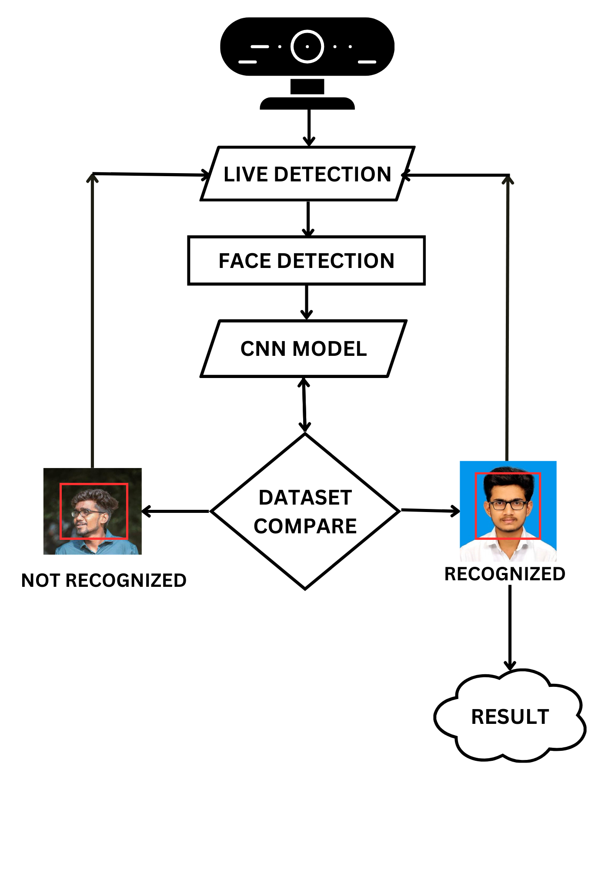
Fig 7.2. WORK FLOW DIAGRAM
7.2.1 Initialization
The Initialization phase is the inception of the face recognition system, marking the beginning of a carefully orchestrated process. This phase involves setting up key parameters and configurations through the AdvancedFacerec class, which acts as the central nervous system of the entire system. During initialization, users are empowered to customize critical parameters, such as the frame resizing factor, face recognition model type, threshold for face comparison, and the number of jitters for face encoding. This customization ensures that the system is tailored to specific requirements, whether it be optimizing for accuracy, speed, or a balance between the two. The Initialization phase lays the groundwork for subsequent stages, defining the system's behavior and characteristics.

7.2.2 Dataset Loading
The Dataset Loading phase is a pivotal step in the workflow, where the system populates its knowledge base with facial images for subsequent recognition tasks. The system follows a modular approach, iterating through folders, each dedicated to an individual. This adaptability ensures compatibility with diverse dataset structures, allowing users to organize their data in a way that makes sense for their specific use case. The method load_encoding_images_from_dataset utilizes the capabilities of the face_recognition library to encode each facial image, creating a comprehensive database of known face encodings and their associated names. This process is not just about loading data; it's about building a dynamic foundation that evolves as new faces are introduced or as the system adapts to changing requirements.

7.2.3 Real-time Face Recognition
The Real-time Face Recognition phase is the heartbeat of the system, where the magic happens in capturing, processing, and recognizing faces from a live webcam feed. This phase involves a continuous capture of frames from the webcam feed, ensuring a real-time and dynamic interaction with the environment. To strike a balance between accuracy and responsiveness, a strategic frame skipping mechanism is employed. The detect_known_faces method, a core functionality of the system, is invoked to identify known faces within the processed frames. The CNN face detection model comes into play, leveraging deep learning techniques to precisely locate faces. This phase is not just about recognizing faces; it's about creating an interactive experience that adapts to the real-time dynamics of the environment.

7.2.4 Face Comparison
The Face Comparison phase is a critical juncture where detected face encodings are compared with known face encodings to determine a match. The user-defined threshold plays a pivotal role in this comparison, influencing the system's sensitivity. By setting a lower threshold, the system is fine-tuned to enhance its ability to accurately recognize faces. This phase is not just about comparing numerical representations; it's about making nuanced decisions based on user-defined criteria. The comparison results determine whether a known face has been identified in the current frame, contributing to the system's ability to make accurate and personalized identifications in real-time.

7.2.5 Display Results
The Display Results phase is where the recognition outcomes are visualized, creating a tangible and user-friendly interface. Rectangles are strategically drawn around detected faces in the webcam feed, providing a visual representation of the recognized individuals. Associated names are overlaid on these rectangles, offering users a clear and intuitive way to understand who has been identified. This phase is not just about displaying information; it's about creating a user-centric interface that enhances transparency and user experience. The visual feedback adds a layer of interpretability to the face recognition process, making it accessible and meaningful to users.

7.2.6 User Interaction
The User Interaction phase marks the conclusion of the workflow, allowing users to intuitively interact with the system. The system persists until the user decides to terminate the application by pressing the 'Esc' key. This simple yet effective termination mechanism enhances the system's practicality, ensuring that users have control over the system's lifecycle. This phase is not just about concluding the process; it's about creating an accessible and user-friendly experience, putting the user in control of when and how the system operates.

7.3 MODULES
A module description provides the in-depth information about the module and it explains the brief description about the supported components. It is the high description of a functional area which consists of set of processes which describes the action of the modules and the package implemented in project.

7.3.1 FACE DETECTION
The Face Detection Module plays a pivotal role in the broader ecosystem of computer vision applications, particularly in scenarios where the identification and localization of human faces are paramount. At its core, this module is tasked with the intricate process of identifying facial regions within images or video frames, a task that requires a nuanced understanding of visual patterns and structures characteristic of human faces. Leveraging the capabilities of the face_recognition library, the module harnesses the power of deep learning, specifically Convolutional Neural Networks, to achieve accurate and robust face detection.

CNNs, a class of deep neural networks, have revolutionized the field of computer vision due to their ability to automatically learn hierarchical representations of visual data. In the context of face detection, CNNs excel at extracting discriminative features from raw pixel data, enabling them to discern subtle facial characteristics across a wide range of images with varying lighting conditions, poses, and backgrounds. The face_recognition library, built upon this foundation, leverages a pre-trained CNN model that has been fine-tuned on vast datasets containing diverse facial images, ensuring its adaptability and generalization capabilities across different scenarios.

One of the critical challenges in face detection is striking a balance between detection accuracy and computational efficiency, especially when processing large volumes of data in real-time applications. To address this challenge, the Face Detection Module incorporates preprocessing techniques aimed at optimizing the performance of the underlying CNN model. A common strategy involves resizing input images to reduce their spatial dimensions, thereby mitigating the computational burden associated with processing high-resolution data. By resizing images, the module not only enhances processing speed but also maintains detection accuracy by preserving essential facial details and features.

Upon preprocessing, the module proceeds to feed the resized images into the CNN model for face detection. Through a series of convolutional, pooling, and activation layers, the model convolves input images to extract hierarchical representations, progressively capturing abstract features indicative of facial structures. These learned representations are then passed through subsequent layers, culminating in the generation of feature maps that highlight potential facial regions within the input image. By analyzing these feature maps, the module identifies candidate regions likely to contain human faces, leveraging learned spatial patterns and contextual cues encoded within the CNN model.

Once candidate regions are identified, the module employs post-processing techniques, such as non-maximum suppression, to refine the detected faces and remove redundant or overlapping detections. Finally, the module outputs the precise locations of detected faces within the input image or video frame, typically represented as bounding boxes or pixel coordinates. These outputted locations serve as vital spatial references, enabling downstream modules, such as the Face Recognition Module, to focus their efforts on analyzing specific regions of interest corresponding to detected faces.

In essence, the Face Detection Module epitomizes the synergy between cutting-edge deep learning algorithms and pragmatic engineering principles, showcasing the potential of AI-driven solutions in addressing real-world challenges. By harnessing the power of CNNs and implementing efficient preprocessing strategies, the module delivers accurate and efficient face detection capabilities, laying the foundation for a myriad of applications spanning security, surveillance, biometrics, human-computer interaction, and beyond. As advancements in AI continue to push the boundaries of what is possible, the Face Detection Module stands as a testament to the transformative impact of technology on reshaping our interactions with the digital world and beyond.

7.3.2 DATA PREPROCESSING
The Data Preprocessing Module serves as a cornerstone in the pipeline of face recognition systems, tasked with the crucial responsibility of preparing and organizing the raw data required for subsequent analysis. At its core, this module orchestrates the loading and preprocessing of encoding images sourced from a dataset directory, laying the groundwork for accurate and efficient face detection and recognition. By meticulously processing each image, the module ensures that all pertinent facial features are captured faithfully, fostering a robust foundation for downstream tasks.

Central to the operation of the Data Preprocessing Module is the handling of encoding images stored within the dataset directory. These images serve as the primary source of information for training and fine-tuning the face recognition system, necessitating a systematic approach to their retrieval and organization. Leveraging file management utilities and directory traversal techniques, the module navigates through the dataset directory, parsing each image file with precision and care.

Upon accessing each image, the Data Preprocessing Module initiates a sequence of preprocessing steps tailored to enhance the quality and utility of the extracted facial information. Foremost among these steps is face detection, wherein the module employs sophisticated algorithms to identify and localize facial regions within the image. By leveraging state-of-the-art techniques, such as the Viola-Jones algorithm or deep learning-based approaches like CNNs, the module ensures the accurate delineation of facial boundaries, even amidst challenging conditions such as varying illumination or occlusions.

Following face detection, the module proceeds to encode the detected facial regions, extracting high-dimensional feature vectors that encapsulate the unique characteristics of each face. This encoding process, facilitated by advanced computer vision libraries like OpenCV or Dlib, involves the transformation of raw pixel data into compact and discriminative representations suitable for subsequent comparison and analysis. By leveraging established encoding techniques, such as Histogram of Oriented Gradients or Convolutional Neural Networks, the module captures intricate facial details while minimizing computational overhead.

Crucially, the Data Preprocessing Module is engineered to handle scenarios where no faces are detected in an image, a common occurrence in real-world datasets characterized by noise and variability. To address this challenge, the module implements robust error handling mechanisms, ensuring the integrity of the preprocessing pipeline under adverse conditions. Whether through the adoption of fallback strategies, such as image augmentation or feature interpolation, or the deployment of anomaly detection algorithms to flag problematic instances, the module safeguards against data inconsistencies and preserves the reliability of downstream analyses.

In essence, the Data Preprocessing Module serves as the linchpin in the face recognition pipeline, bridging the gap between raw data and actionable insights. Through meticulous image loading, face detection, and encoding, the module lays the groundwork for accurate and reliable face recognition, enabling subsequent modules to operate with confidence and efficacy. By embracing a holistic approach to data preprocessing and incorporating robust error handling mechanisms, the module paves the way for the seamless integration of face recognition technologies into diverse real-world applications, from security and surveillance to human-computer interaction and beyond.

7.3.3 FACE RECOGNITION
The Face Recognition Module constitutes a pivotal component within the architecture of face recognition systems, wielding the capability to discern and identify individuals within a given set of detected faces. At its essence, this module operates through a multifaceted process of comparing the features extracted from detected faces with known face encodings, facilitating the recognition and attribution of identities. Central to its functionality is the employment of a threshold-based approach, wherein matches are determined based on similarity scores derived from the comparison of feature vectors. This intricate interplay of algorithms and techniques enables the module to provide real-time recognition capabilities across a spectrum of applications, spanning security, access control, surveillance, and beyond.

At the heart of the Face Recognition Module lies the intricate process of comparing detected faces with a repository of known face encodings, which encapsulate the unique characteristics of individuals' facial features. Leveraging the power of advanced machine learning algorithms, such as Support Vector Machines, k-Nearest Neighbors, or deep neural networks, the module computes similarity scores between the extracted feature vectors, discerning subtle nuances and distinguishing traits that define individual identities. This comparative analysis serves as the cornerstone of the recognition process, enabling the module to infer the likelihood of a match between a detected face and a known identity with a high degree of accuracy.

Crucially, the Face Recognition Module operates within the confines of a threshold-based framework, wherein matches are determined based on predefined thresholds governing the acceptance or rejection of similarity scores. By establishing appropriate thresholds calibrated to the specific requirements and constraints of the application domain, the module can effectively balance the trade-off between false positives and false negatives, optimizing recognition accuracy while minimizing errors. This thresholding mechanism introduces a layer of flexibility and adaptability, allowing the module to accommodate variations in environmental conditions, image quality, and other factors that may influence the recognition process.

Upon identifying a match above the threshold, the Face Recognition Module proceeds to attribute a name or label to the detected face, thereby completing the recognition process and providing actionable insights for downstream applications. This attribution of identities facilitates real-time recognition capabilities, empowering systems to make informed decisions and take appropriate actions based on the recognized individuals' identities. Whether in the context of access control systems, where authorized personnel are granted entry based on their recognized identities, or in surveillance applications, where individuals of interest are flagged for further scrutiny, the module's ability to provide instantaneous recognition capabilities is indispensable.

In conclusion, the Face Recognition Module stands as a testament to the transformative power of machine learning and computer vision in enabling real-time recognition capabilities across diverse applications. By leveraging threshold-based comparisons and advanced feature extraction techniques, the module facilitates the accurate and efficient recognition of individuals within a given set of detected faces, unlocking a myriad of possibilities for enhancing security, efficiency, and convenience in various domains. As advancements in artificial intelligence continue to propel the boundaries of what is achievable, the Face Recognition Module remains at the forefront of innovation, driving the evolution of face recognition technologies and their integration into everyday life.

7.3.4 IMAGE/VIDEO ANALYSIS
The Image/Video Analysis Module constitutes a pivotal component in the landscape of computer vision systems, serving as the conduit through which raw visual data is transformed into actionable insights. Leveraging the robust capabilities of the OpenCV library, this module orchestrates the capture and analysis of frames sourced from a camera feed, enabling real-time processing and interpretation of visual information. At its core, the module operates through a sophisticated pipeline, wherein each frame is subjected to scrutiny by the Face Recognition Module, which identifies and attributes identities to known faces. Subsequently, the module leverages this information to annotate detected faces with bounding boxes and display their associated names on the frame, thereby facilitating visual identification and enhancing situational awareness. This seamless integration of image and video analysis capabilities empowers the module to unlock a myriad of applications, ranging from surveillance and access control to crowd monitoring and beyond, where real-time insights and actionable intelligence are paramount.

Central to the functionality of the Image/Video Analysis Module is its ability to interface with OpenCV, a versatile computer vision library renowned for its extensive suite of functionalities and robust performance. Leveraging OpenCV's APIs and utilities, the module orchestrates the capture of frames from a camera feed, leveraging hardware-accelerated capabilities to ensure high-speed acquisition and processing. By interfacing directly with the camera hardware, the module enables real-time analysis of visual data, providing instantaneous insights into the dynamic environment captured by the camera.

Upon capturing each frame, the Image/Video Analysis Module initiates a series of processing steps aimed at extracting actionable insights from the visual data. Central to this process is the integration with the Face Recognition Module, which leverages pre-trained models and sophisticated algorithms to identify known faces within the frame. By interfacing with the Face Recognition Module, the module harnesses the power of machine learning and pattern recognition to discern the identities of individuals present in the scene, thereby laying the foundation for subsequent analysis and decision-making.

Once known faces are detected and identified, the Image/Video Analysis Module proceeds to annotate the frame with bounding boxes, delimiting the spatial extent of each detected face. Additionally, the module overlays text labels atop each bounding box, displaying the names or identities associated with the recognized individuals. This visual augmentation serves as a powerful aid for visual identification, enhancing situational awareness and enabling operators to make informed decisions based on the recognized individuals' identities.

Crucially, the Image/Video Analysis Module operates in real-time, facilitating instantaneous analysis and interpretation of visual data. This real-time capability is instrumental in applications such as surveillance, access control, and crowd monitoring, where timely insights and rapid decision-making are paramount. By providing a seamless interface between raw visual data and actionable intelligence, the module empowers users to extract valuable insights from the camera feed, enhancing security, efficiency, and situational awareness across a spectrum of domains.

In conclusion, the Image/Video Analysis Module stands as a testament to the transformative potential of computer vision technologies in unlocking actionable insights from visual data. By leveraging OpenCV for frame capture and analysis, and integrating with the Face Recognition Module for facial identification, the module enables real-time video analysis, empowering applications ranging from surveillance and access control to crowd monitoring and beyond. As advancements in computer vision continue to drive innovation, the Image/Video Analysis Module remains at the forefront of enabling real-time insights and actionable intelligence from visual data, paving the way for a safer, more efficient, and more informed future.

7.3.5 ACCURACY ANALYSIS
The Accuracy Analysis Module serves as a critical component within the framework of face recognition systems, providing a comprehensive evaluation of the system's performance and efficacy. Through the rigorous assessment of key comparison metrics such as precision, recall, and F1-score, this module offers invaluable insights into the system's accuracy, reliability, and effectiveness in recognizing and attributing identities to detected faces. By scrutinizing true positive, false positive, true negative, and false negative rates, the module unveils the system's strengths and weaknesses, enabling stakeholders to make informed decisions and optimizations. Moreover, the module may incorporate additional statistical analyses, encompassing a wide array of methodologies and techniques to measure system performance comprehensively and robustly.

At the core of the Accuracy Analysis Module lies the evaluation of key performance metrics, including precision, recall, and F1-score, which offer quantitative measures of the system's accuracy and effectiveness in face recognition. Precision, defined as the ratio of true positive identifications to the total number of identifications made by the system, provides insights into the system's ability to correctly identify known faces while minimizing false positives. A high precision score signifies a low rate of false identifications, indicative of the system's reliability and discriminative prowess. Similarly, recall, also known as sensitivity, quantifies the system's ability to correctly identify all relevant instances of known faces within the dataset, capturing the proportion of true positives correctly identified by the system. A high recall score reflects the system's capability to accurately detect known faces while mitigating false negatives, thus underscoring its robustness and comprehensiveness in face recognition tasks. Furthermore, the F1-score, which represents the harmonic mean of precision and recall, offers a balanced assessment of the system's performance, incorporating both precision and recall into a single metric. By considering the trade-off between precision and recall, the F1-score provides a holistic view of the system's accuracy and effectiveness, offering stakeholders a comprehensive understanding of its performance.

In addition to evaluating precision, recall, and F1-score, the Accuracy Analysis Module scrutinizes key classification metrics, including true positive, false positive, true negative, and false negative rates, which offer deeper insights into the system's behavior and performance. True Positive instances represent cases where known faces are correctly identified by the system, while False Positive instances correspond to cases where unknown faces are incorrectly identified as known faces. Conversely, True Negative instances denote cases where unknown faces are correctly classified as unknown, and False Negative instances encompass cases where known faces are incorrectly classified as unknown. By quantifying these classification outcomes, the module unveils the system's strengths and weaknesses, shedding light on areas for improvement and optimization. Moreover, the module may incorporate additional statistical analyses, including Receiver Operating Characteristic curve analysis, Area Under the Curve computations, and error analysis techniques, to further elucidate the system's performance and behavior. ROC curve analysis provides insights into the trade-off between true positive and false positive rates across varying classification thresholds, offering a nuanced perspective on the system's discriminative capabilities and decision-making thresholds. Similarly, AUC computations quantify the overall discriminative performance of the system, offering a concise summary of its ability to distinguish between known and unknown faces. Furthermore, error analysis techniques, such as confusion matrix analysis and error decomposition, enable stakeholders to identify common sources of misclassification and error, facilitating targeted optimizations and improvements.

In conclusion, the Accuracy Analysis Module serves as a cornerstone within the framework of face recognition systems, offering a comprehensive evaluation of the system's accuracy, reliability, and effectiveness. Through the rigorous assessment of key comparison metrics such as precision, recall, and F1-score, as well as key classification metrics including true positive, false positive, true negative, and false negative rates, the module provides stakeholders with invaluable insights into the system's performance and behavior. Moreover, by incorporating additional statistical analyses, including ROC curve analysis, AUC computations, and error analysis techniques, the module offers a nuanced and comprehensive understanding of the system's strengths and weaknesses, enabling targeted optimizations and improvements. As advancements in face recognition technologies continue to drive innovation, the Accuracy Analysis Module remains essential in ensuring the reliability, efficacy, and performance of face recognition systems across diverse domains and applications.

7.3.6 REAL-TIME MONITORING
The Real-time Monitoring Module represents a cornerstone in the architecture of complex systems, providing continuous oversight and management of the system's performance and resource utilization in real-time. Through its robust monitoring capabilities, this module offers stakeholders unprecedented visibility into the system's operation, enabling timely detection and resolution of issues or anomalies that may arise. By leveraging advanced alerting mechanisms, the module ensures prompt intervention and troubleshooting, minimizing downtime and optimizing system efficiency. Moreover, the Real-time Monitoring Module goes beyond mere detection, offering comprehensive visualizations and dashboards that provide intuitive insights into system status and performance trends. These visualizations empower stakeholders to make informed decisions and take proactive measures to enhance system reliability, scalability, and performance, thereby driving continuous improvement and optimization efforts.

At the core of the Real-time Monitoring Module lies its ability to monitor the system's performance and resource utilization in real-time, providing stakeholders with a comprehensive understanding of the system's operation. Leveraging a diverse array of monitoring tools and techniques, the module continuously collects and analyzes data pertaining to system metrics such as CPU utilization, memory usage, network activity, and throughput. By monitoring these Key Performance Indicators in real-time, the module identifies any deviations from expected norms or thresholds, signaling potential issues or anomalies that require attention.

Crucially, the Real-time Monitoring Module incorporates advanced alerting mechanisms to notify stakeholders of any detected issues or anomalies in real-time. Through the configuration of customizable alerting rules and thresholds, the module ensures that stakeholders receive timely notifications via email, SMS, or other communication channels, enabling prompt intervention and troubleshooting. Whether it be a sudden spike in CPU utilization, a memory leak, or a network outage, the module ensures that stakeholders are promptly informed, allowing them to take proactive measures to mitigate the impact and restore normal operation.

Furthermore, the Real-time Monitoring Module offers comprehensive visualizations and dashboards that provide stakeholders with intuitive insights into system status and performance trends. Whether it be through real-time dashboards that provide a snapshot of system health or historical trend analysis that highlights performance patterns over time, the module empowers stakeholders to make data-driven decisions and take proactive measures to optimize system performance and reliability.

In addition to monitoring system performance and resource utilization, the Real-time Monitoring Module plays a critical role in facilitating informed decision-making and optimization efforts. Whether it be through capacity planning, performance tuning, or infrastructure optimization, the module serves as a valuable tool for driving continuous improvement and optimization efforts across the organization.

In conclusion, the Real-time Monitoring Module represents a cornerstone in the architecture of complex systems, providing continuous oversight and management of system performance and resource utilization in real-time. Through its robust monitoring capabilities, advanced alerting mechanisms, and comprehensive visualizations, the module empowers stakeholders to detect and resolve issues or anomalies promptly, optimize system performance, and drive continuous improvement efforts. As organizations increasingly rely on complex systems to support their operations, the Real-time Monitoring Module remains essential in ensuring the reliability, scalability, and performance of these systems, thereby enabling organizations to achieve their business objectives efficiently and effectively.

CHAPTER 8

CONCLUSION AND FUTURE WORK

8.1 CONCLUSION
The real-time face recognition system presented here utilizes advanced techniques such as CNN-based face detection and multi-jittered face encoding to accurately identify known faces from a dataset. By leveraging the Face Recognition library, it can efficiently process frames from a live camera feed, detecting and recognizing faces in real-time. The system exhibits flexibility in handling various face orientations and lighting conditions, thanks to the robustness of the underlying algorithms. However, it's essential to note that the system's accuracy heavily relies on the quality and diversity of the dataset used for training. Additionally, while the system performs well in controlled environments, its performance may degrade in more challenging scenarios with occlusions or extreme variations in appearance. Regular updates and improvements to the dataset, along with potential enhancements in algorithmic techniques, could further refine the system's performance for real-world applications.

8.2 FUTURE WORK
Dynamic Threshold Adjustment:
This enhancement involves creating a mechanism to dynamically adjust the threshold used for face recognition based on environmental factors such as lighting conditions, image quality, and distance from the camera. This could involve implementing algorithms that analyze image characteristics in real-time to determine the optimal threshold for accurate face matching. Techniques such as histogram equalization, adaptive thresholding, and machine learning models could be explored to develop robust threshold adjustment mechanisms.

Face Tracking and Re-identification:
Face tracking involves the continuous monitoring and localization of faces in a video stream, while re-identification focuses on associating faces across different frames or camera views. Integrating these capabilities into the face recognition system enhances its ability to maintain continuity in recognition, especially in scenarios where faces may temporarily go out of view or undergo occlusion. Techniques such as Kalman filtering, deep learning-based tracking algorithms, and feature-based matching can be utilized for effective face tracking and re-identification.

Side Face Detection:
Detecting side faces involves identifying and localizing faces that are not facing the camera directly. This can be achieved by augmenting the existing face detection module to handle non-frontal face orientations. Techniques such as profile face detectors, which are specifically trained to detect side faces, can be integrated into the system. These detectors utilize features such as head contour, ear position, and facial landmarks to accurately locate side faces. Additionally, deep learning-based approaches, such as Convolutional Neural Networks, can be trained on annotated datasets containing side face images to improve detection performance. By incorporating side face detection, the system becomes more robust and capable of recognizing faces from various angles and orientations.

Age Calculation:
Age estimation involves predicting the age of individuals based on their facial features. This functionality can be implemented using machine learning models trained on annotated datasets containing images labeled with age labels. Convolutional neural networks are commonly used for age estimation tasks, where the network learns to extract age-related features from facial images and predict the corresponding age range or exact age. Pre-processing techniques such as face alignment and normalization can help improve the accuracy of age estimation by aligning facial landmarks and reducing variability in facial appearance. Age estimation models can be integrated into the face recognition system to provide additional demographic information about recognized individuals. This information can be useful for various applications such as targeted advertising, age-restricted access control, and demographic analysis.

Privacy Preservation:
Privacy-preserving mechanisms aim to protect individuals' identities while still enabling effective face recognition for authorized purposes. This could involve techniques such as face anonymization, where facial features are obscured or modified to prevent identification, or encryption techniques to secure facial data during transmission and storage. Privacy-enhancing technologies such as federated learning, homomorphic encryption, and differential privacy can also be explored to ensure compliance with privacy regulations and protect users' privacy rights.
Parallelization and Optimization:
Parallelization and optimization techniques aim to improve the efficiency and performance of face recognition algorithms, particularly for deployment on resource-constrained platforms such as edge devices. Leveraging hardware acceleration techniques such as GPU parallelization, model optimization, and quantization can significantly speed up inference and enable real-time performance. Additionally, optimizing algorithmic components such as feature extraction, matching algorithms, and memory management can further enhance the system's efficiency and scalability.

Cross-domain Generalization:
Cross-domain generalization involves training face recognition models on diverse datasets encompassing a wide range of demographics, ethnicities, and environmental conditions to reduce biases and improve recognition accuracy across different domains. This could involve collecting and curating representative datasets from various sources, applying data augmentation techniques to enhance dataset diversity, and employing transfer learning approaches to adapt pre-trained models to new domains. Additionally, fairness-aware training methodologies and bias mitigation techniques can be explored to ensure fair and equitable recognition for all demographics and mitigate algorithmic biases.

APPENDIX-1
SOURCE CODE
import os
import glob
import cv2
import face_recognition
import numpy as np
class AdvancedFacerec:
def __init__(self):
self.known_face_encodings = []
self.known_face_names = []
self.frame_resizing = 0.5
self.face_recognition_model = "cnn"
self.threshold = 0.7
self.num_jitters = 2
def load_encoding_images_from_dataset(self, dataset_path):
person_folders = glob.glob(os.path.join(dataset_path, "*"))
print("{} persons found in the dataset.".format(len(person_folders)))
for person_folder in person_folders:
person_name = os.path.basename(person_folder)
print("Loading images for person: {}".format(person_name))
image_files = glob.glob(os.path.join(person_folder, "*.*"))
if not image_files:
print("No images found for {}".format(person_name))
continue
for img_path in image_files:
img = face_recognition.load_image_file(img_path)
img_encodings = face_recognition.face_encodings(img, num_jitters=self.num_jitters)
if not img_encodings:
print("No face found in {}".format(img_path))
continue
for encoding in img_encodings:
self.known_face_encodings.append(encoding)
self.known_face_names.append(person_name)
print("Encoding images loaded")
def detect_known_faces(self, frame):
small_frame = cv2.resize(frame, (0, 0), fx=self.frame_resizing, fy=self.frame_resizing)
face_locations = face_recognition.face_locations(small_frame, model=self.face_recognition_model)
face_encodings = face_recognition.face_encodings(small_frame, face_locations, num_jitters=self.num_jitters)
face_names = []
if len(face_encodings) == 0:
return np.array([]), []
for face_encoding in face_encodings:
matches = face_recognition.compare_faces(self.known_face_encodings, face_encoding, tolerance=self.threshold)
name = "Unknown"
face_distances = face_recognition.face_distance(self.known_face_encodings, face_encoding)
if len(face_distances) == 0:
continue
best_match_index = np.argmin(face_distances)
if matches[best_match_index]:
name = self.known_face_names[best_match_index]
face_names.append(name)
face_locations = np.array(face_locations)
face_locations = face_locations / self.frame_resizing
return face_locations.astype(int), face_names
if __name__ == "__main__":
sfr = AdvancedFacerec()
sfr.load_encoding_images_from_dataset("data/")
cap = cv2.VideoCapture(0)
frame_skip = 3
count = 0
while True:
ret, frame = cap.read()
if count % frame_skip == 0:
face_locations, face_names = sfr.detect_known_faces(frame)
for face_loc, name in zip(face_locations, face_names):
y1, x2, y2, x1 = face_loc[0], face_loc[1], face_loc[2], face_loc[3]
cv2.rectangle(frame, (x1, y1), (x2, y2), (0, 0, 200), 4)
cv2.putText(frame, name, (x1, y1 - 10), cv2.FONT_HERSHEY_DUPLEX, 1, (0, 0, 200), 2)
cv2.imshow("Frame", frame)
count += 1
key = cv2.waitKey(1)
if key == 27:
break
cap.release()
cv2.destroyAllWindows()

APPENDIX – 2

SCREENSHOTS

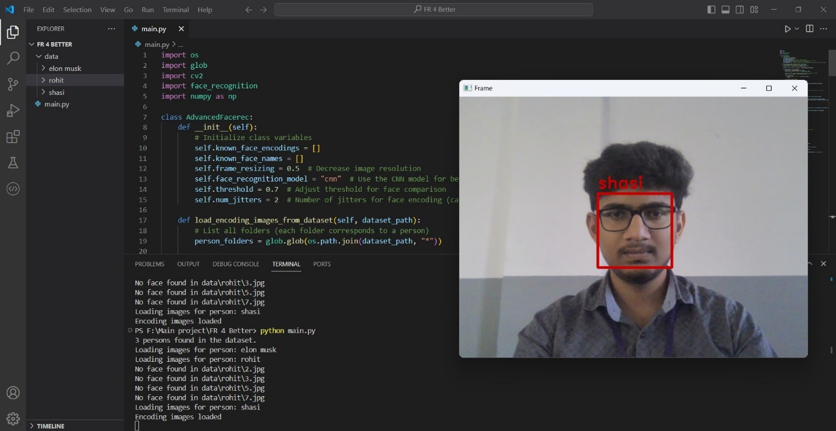
KNOWN PERSON 1

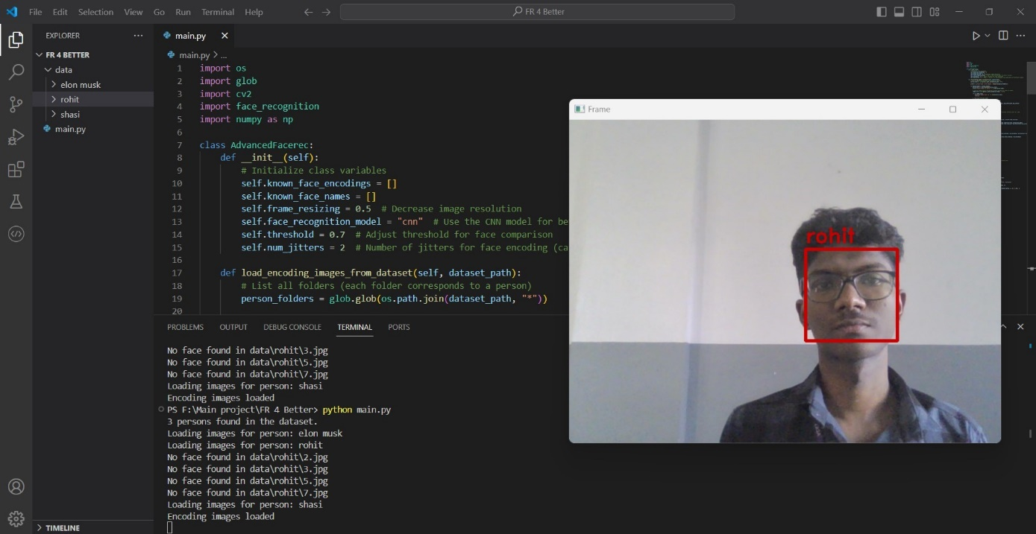

KNOWN PERSON 2

KNOWN PERSON 3

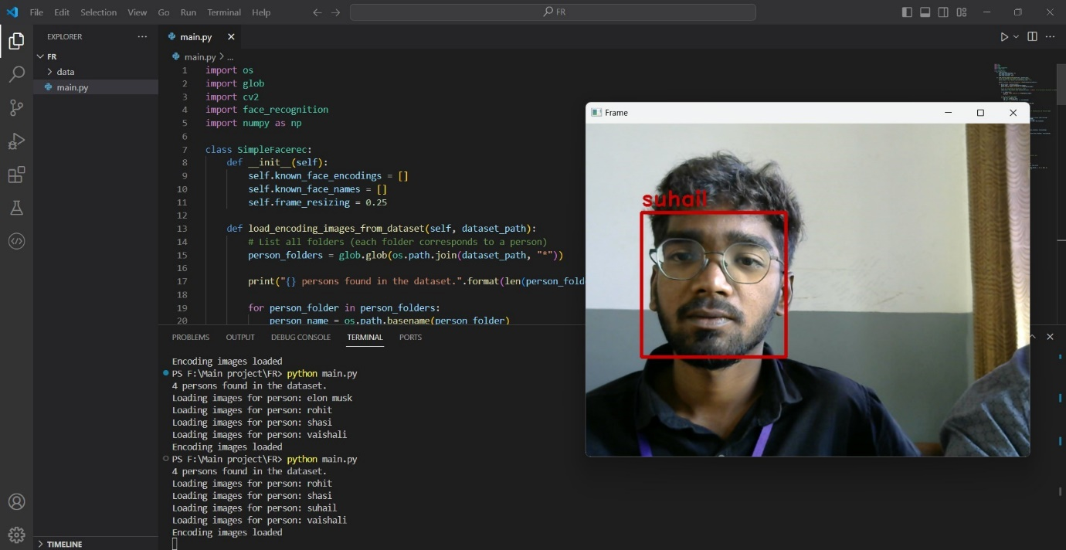
KNOWN PERSON 4


UNKNOWN PERSON

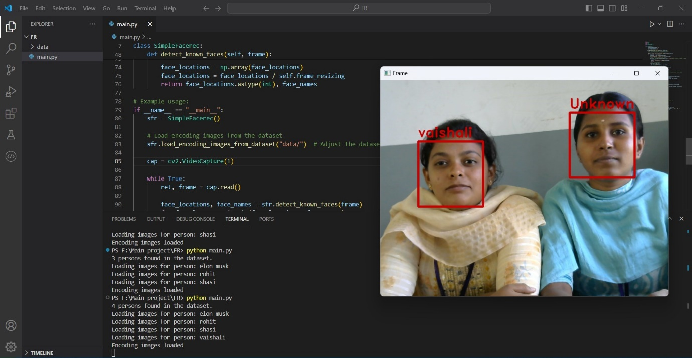
KNOWN PERSON AND UNKNOWN PERSON

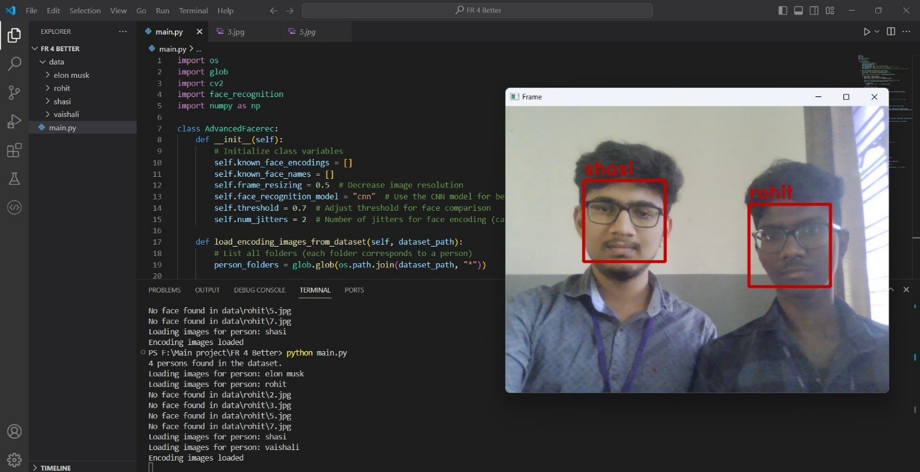
KNOWN PERSONS WITH DIM LIGHT

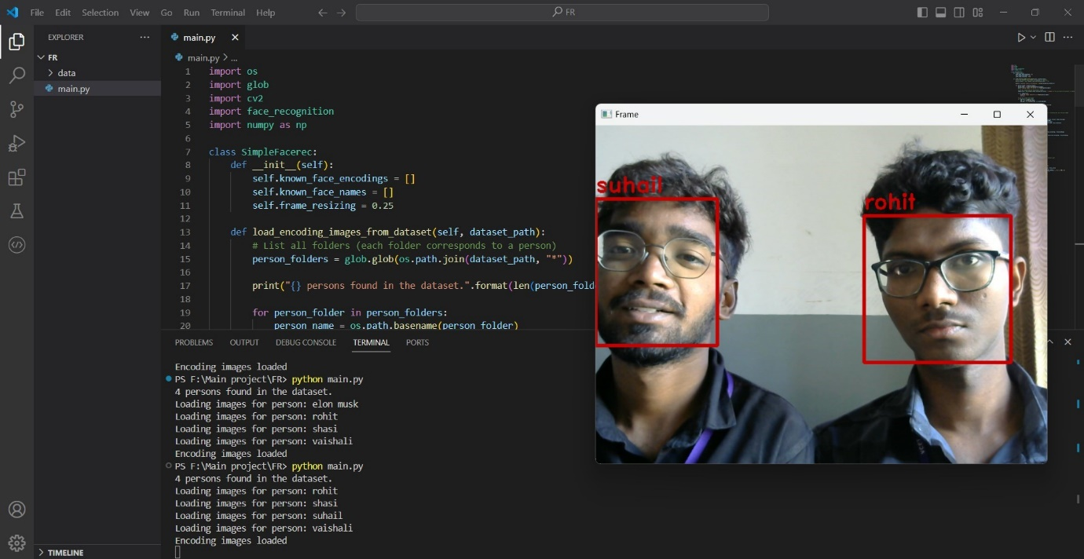

KNOWN PERSONS WITH MEDIUM LIGHT

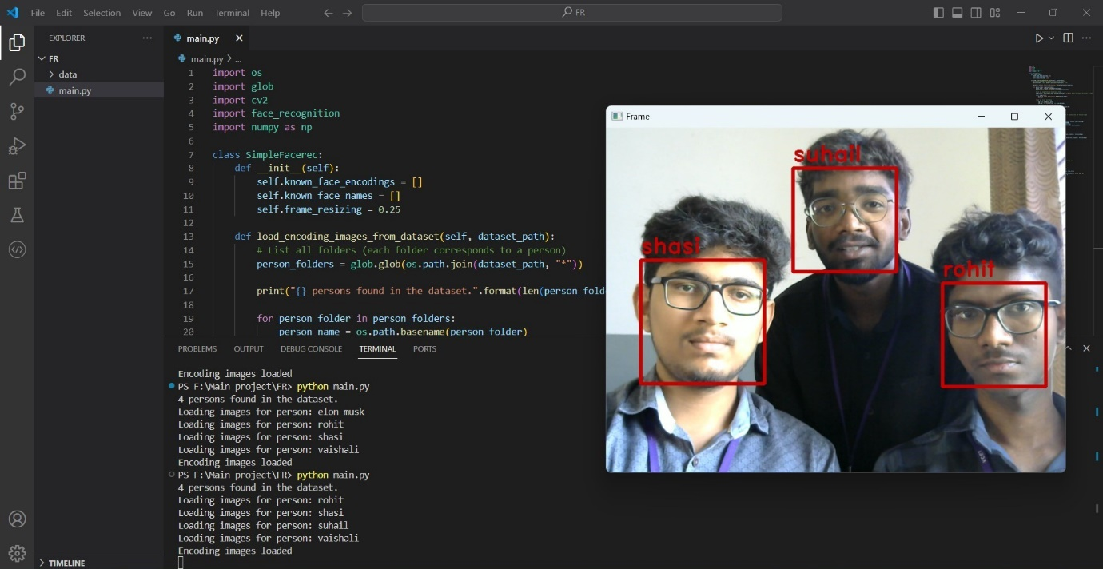
KNOWN PERSONS WITH BRIGHT LIGHT

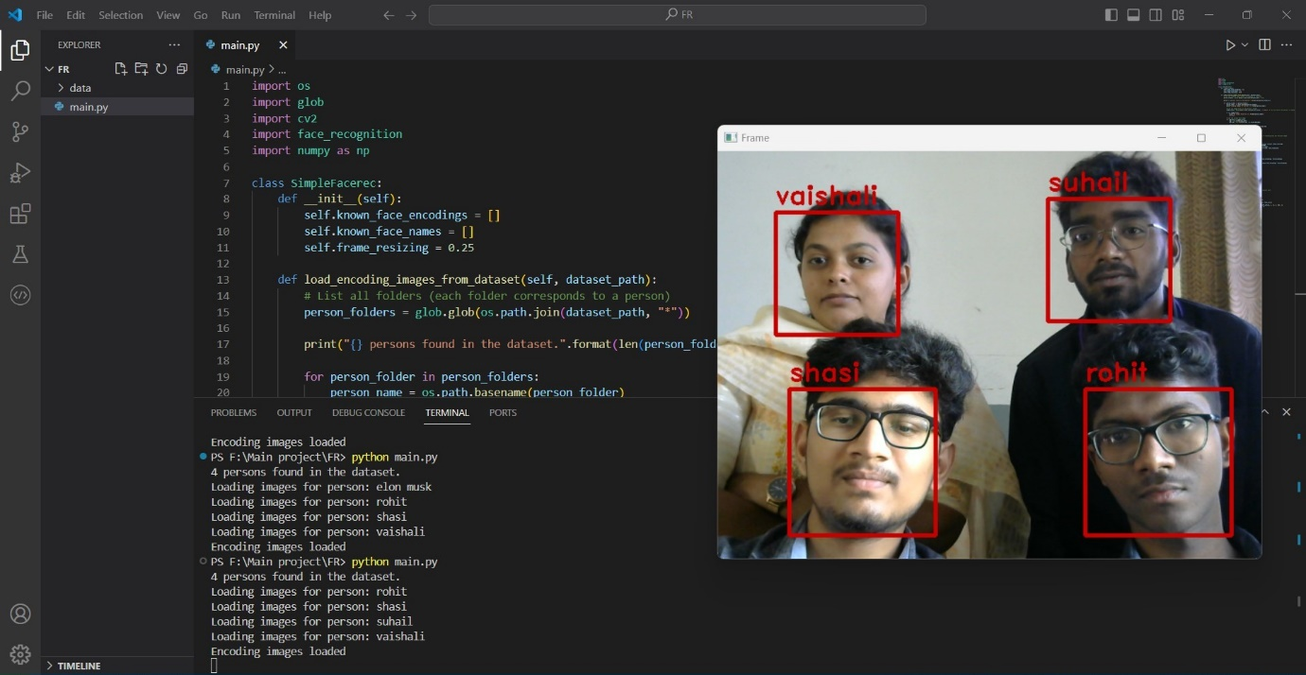
MUTIPLE KNOWN PERSONS

REFERENCES

- Ahmed Rimaz Faizabadi , Hasan Firdaus Bin Mohd Zaki,Zulkifli Bin Zainal Abidin, Nik Nur Wahidah Nik Hashim and Muhammad Afif Bin Husman, "Efficient Region of Interest Based Metric Learning for Effective Open World Deep Face Recognition Applications", IEEE Access ,https://ieeexplore.ieee.org/document/9833501
- Fadi Mohammad Alsuhimat and Fatma Susilawati Mohamad, "Hybrid Method of Feature Extraction for Signatures Verification Using CNN and HOG a Multi-Classification Approach", 10.1109/ACCESS.2023.3252022,IEEE Access, https://ieeexplore.ieee.org/document/10058518
- Hao Yang and Xiaofeng Han, "Face Recognition Attendance System Based on Real-time Video Processing", 10.1109/ACCESS.2020.3007205, IEEE Access, https://ieeexplore.ieee.org/stamp/stamp.jsp?tp=&arnumber=9138372
- Hajrah Sultan, Asim Waris, Muhammad Hamza Zafar, Haris Ijaz, Saba Anwer and Moaz Sarwar, "Real Time Face Recognition Based Attendance System For University Classroom", March 2022 10.1109/ICAI55435.2022.9773650, https://www.researchgate.net/publication/360665342_Real_Time_Face_Recognition_Based_Attendance_System_For_University_Classroom

- Hyun-Bin Kim , Nakhoon Choi , Hye-Jeong Kwon and Heeyoul Kim, "Surveillance System for Real-Time High-Precision Recognition of Criminal Faces From Wild Videos", 10.1109/ACCESS.2023.3282451, IEEE Access, https://ieeexplore.ieee.org/document/10143202
- Hyung-Jin Mun and Min-Hye Lee, "Design for Visitor Authentication Based on Face Recognition Technology Using CCTV" , 10.1109/ACCESS.2022.3223374,IEEE Access, https://ieeexplore.ieee.org/document/9955529
- Michael Josep and Khaled Elleithy , "Beyond Frontal Face Recognition", 10.1109/ACCESS.2023.3258444, IEEE Access, https://ieeexplore.ieee.org/document/9138372
- Muhammad Sohail , Ijaz Ali Shoukat , Abd Ullah Khan, Haram Fatima, Mohsin Raza Jafri , Muhammad Azfar Yaqub and Antonio Liotta , "Deep Learning Based Multi Pose Human Face Matching System, 10.1109/ACCESS.2024.3366451, IEEE Access, https://ieeexplore.ieee.org/document/10436686
- Shinfeng D. Lin and Paulo E. Linares toya, "Pose-Invariant Face Recognition via Facial Landmark Based Ensemble Learning" , 10.1109/ACCESS.2023.3271997, IEEE Access, https://ieeexplore.ieee.org/document/10113633
- Syam Kakarla, Priyaranjan Gangula, M.Sai Rahul, C. Sai Charan Singh and T. Hitendra Sarma, "Smart Attendance Management System Based on Face Recognition Using CNN", 2020 IEEE-HYDCON, https://ieeexplore.ieee.org/document/9242847
- Vinayak Bharadi, Mr.Rutik Sansare, Mr.Tushar Padelkar and Mr.Vishant Shinde, "Real Time Face Recognition System Using Convolutional Neural Network", 2022 IJCRT | Volume 10, Issue 4 April-2022, https://ijcrt.org/papers/IJCRTO020015.pdf
- Yusuf Perwej, "Face Recognition Based Automated Attendance Management System", February 2022, Volume 9, 10.32628/IJSRST229147, https://www.researchgate.net/publication/358722010_Face_Recognition_Based_Automated_Attendance_Management_System





















